1. Create a square matrix with random integer values(use randint()) and use appropriate functions to find:

i) inverse

ii) rank of matrix

iii) Determinant

iv) transform matrix into 1D array

v) eigen values and vectors

2. Create a matrix X with suitable rows and columns

i) Display the cube of each element of the matrix using different methods

(use multiply(), *, power(),**)

ii) Display identity matrix of the given square matrix.

iii) Display each element of the matrix to different powers.

iv) Create a matrix Y with same dimension as X and perform the operation X2+2Y

1. Multiply a matrix with a submatrix of another matrix and replace the same in larger matrix.

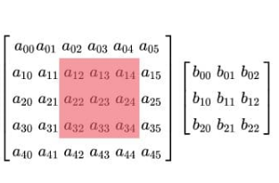

1. Given 3 Matrices A, B and C. Write a program to perform matrix multiplication of the 3 matrices.
2. Write a program to check whether given matrix is symmetric or Skew Symmetric.

Solving systems of equations with numpy

One of the more common problems in linear algebra is solving a matrix-vector equation.

Here is an example. We seek the vector x that solves the equation

A X = b

Where 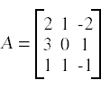 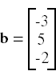

And X=A-1 b.

Numpy provides a function called solve for solving such eauations.

1. Write a program to find out the value of X using **solve(),** given **A** and **b** as above

Singular value Decomposition

Matrix decomposition, also known as matrix factorization, involves describing a given matrix using its constituent elements.

The Singular-Value Decomposition, or SVD for short, is a matrix decomposition method for reducing a matrix to its constituent parts in order to make certain subsequent matrix calculations simpler. This approach is commonly used in reducing the no: of attributes in the given data set.

**M= U ∑V^T**

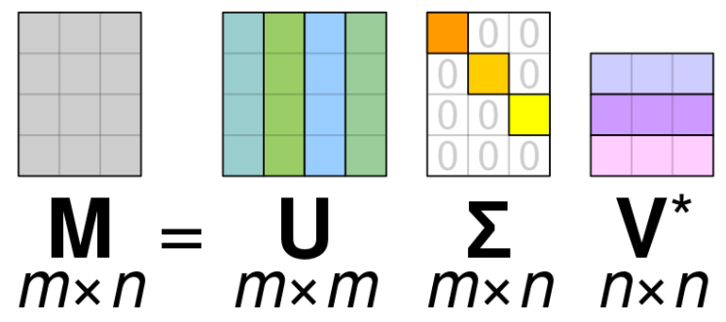

* **M**-is original matrix we want to decompose
* **U**-is left singular matrix (columns are left singular vectors). **U** columns contain eigenvectors of matrix **MM**ᵗ
* **Σ**-is a diagonal matrix containing singular (eigen) values.
* **V**-is right singular matrix (columns are right singular vectors). **V** columns contain eigenvectors of matrix **M**ᵗ**M**

**Numpy** provides a function for performing svd, which decomposes the given matrix into 3 matrices.

1. Write a program to perform the SVD of a given matrix. Also reconstruct the given matrix from the 3 matrices obtained after performing SVD.